TASK 1:
import java.util.Scanner;
class Box{
//default Constructor
int width , height;
public Box (){
width = 1;
height = 1;
}
//Parametrized Constructor
public Box(int w, int h){
width = w;
height = h;
}
Box(Box b1){
Scanner sc1 = new Scanner(System.in);
this.width=b1.width;
this.height=sc1.nextInt();
}
void print (){
System.out.println("width: " + width +" height: "+ height);
}
}
public class task1 {
public static void main(String[] args) {
int a,b;
Scanner sc = new Scanner(System.in);
System.out.println("Enter width and height: ");
a = sc.nextInt();
b = sc.nextInt();
if (a>=0 && b>=0){
Box b1 = new Box();
Box b2 = new Box(a,b);
Box b3 = new Box(b1);
System.out.println("Box 1: ");
b1.print();
System.out.println("Box 2: ");
b2.print();
System.out.println("Box 3: ");
b3.print();
}
else {
System.out.println("Invalid Input, Enter positive value");
}
}
}
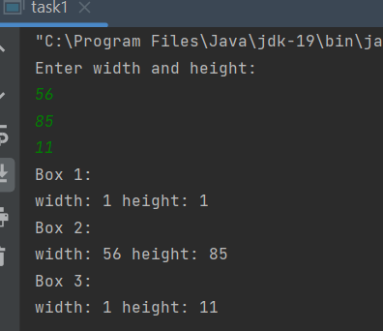
TASK 2:
public class task2 {
public String language;
public task2(){
language = "JAVA";
}
public task2(String lang){
language = lang;
}
public String Result1(){
System.out.println("Language: " + language);
return null;
}
}
class task{
public static void main(String[] args) {
task2 ln = new task2();
task2 ln2 = new task2("C");
String s = ln.Result1();
String s2 = ln2.Result1();
}
}
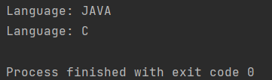
TASK 3:
import java.util.Scanner;
public class task3 {
public static void main(String[] args) {
Scanner m = new Scanner(System.in);
Holiday h1 = new Holiday ("Independence day",14,"August");
Holiday h2 = new Holiday (h1);
boolean flag = Holiday.inSameMonth(h1,h2);
System.out.println("Month is same for both days: "+ flag);
}
}
class Holiday {
String name;
int day;
String month;
Holiday(String name, int day, String month) {
this.name = name;
this.day = day;
this.month = month;
}
Holiday(Holiday h) {
this.name = h.name;
this.day = h.day;
this.month = h.month;
}
public static boolean inSameMonth(Holiday a, Holiday s) {
if (a.month == s.month) {
return Boolean.TRUE;
} else {
return Boolean.FALSE;
}
}
}
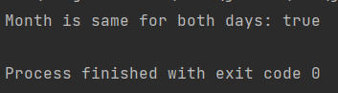
TASK4:
import java.util.Scanner;
public class task4 {
public static void main(String[] args) {
Scanner m = new Scanner(System.in);
System.out.println("input the water level of tank");
int c = m.nextInt();
tank level = new tank(c);
tank.finalize(level);
}
}
class tank {
int capacity;
tank(int capacity) {
this.capacity = capacity;
}
protected static void finalize(tank o) {
if (o.capacity == 0) {
o = null;
System.gc();
System.out.println("the object is destroyed");
} else {
System.out.println("the level of water is " + o.capacity);
}
}
}
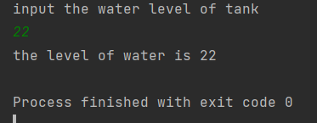

TASK 5:
public class task5 {
public static void main(String[] args) {
GarbageCollection g1 = new GarbageCollection();
GarbageCollection.finalise(g1);
GarbageCollection g2 = new GarbageCollection();
g1=g2;
new GarbageCollection();
System.gc();
}
}
class GarbageCollection {
GarbageCollection(){
System.out.println("object created");
}
static void finalise(GarbageCollection a){
a = null;
// System.gc();
System.out.println("object deleted");
}
}
